**Assignment 3: Git**

Creating git repo on local machine :

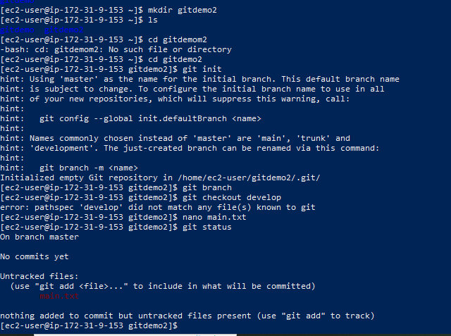

Commiting main.txt to the main branch.

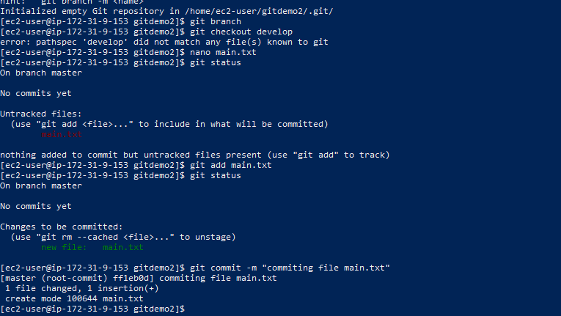

Four branches – develop, f1, f2 and master are created and the relevant .txt files are committed in the specific branches.

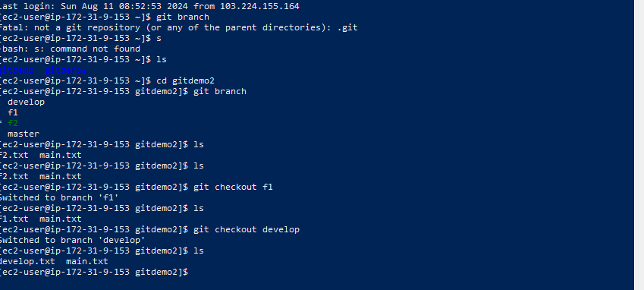

**Creating repo on github:**

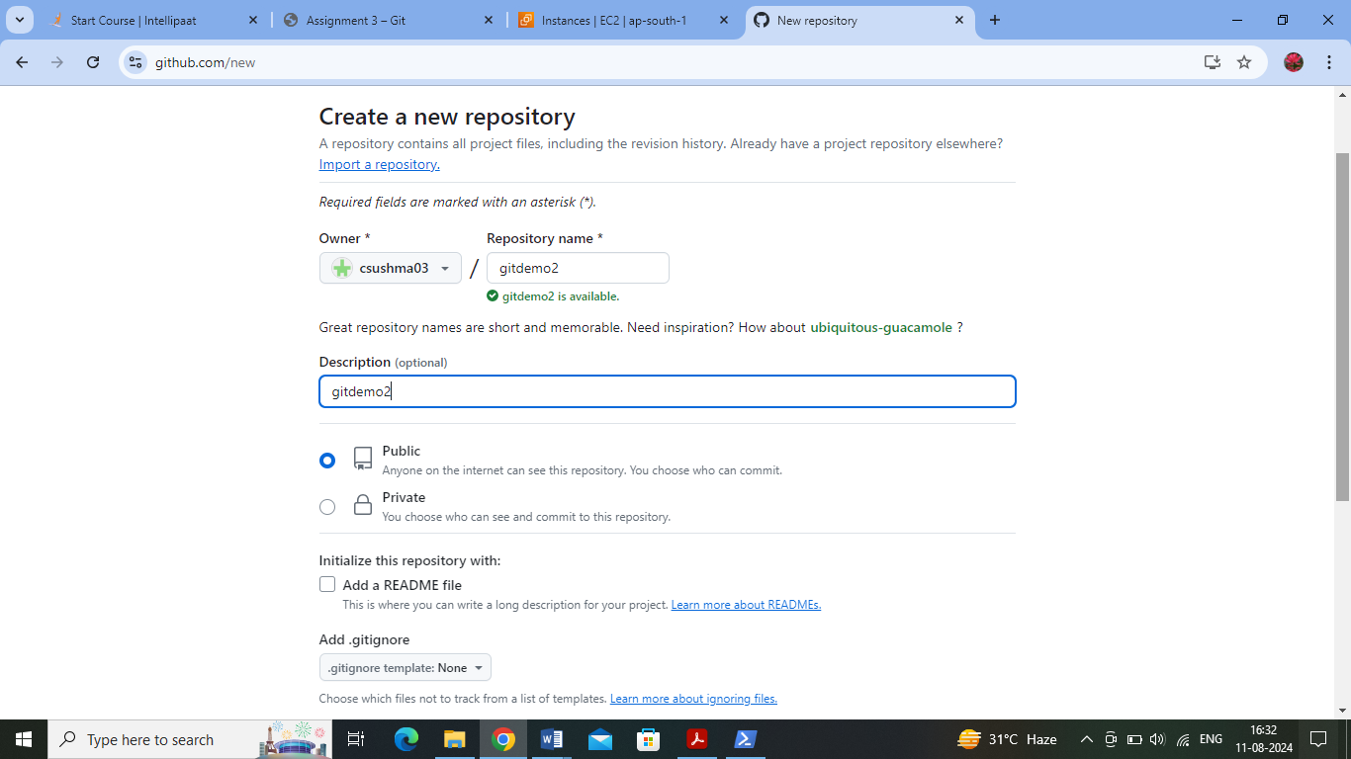

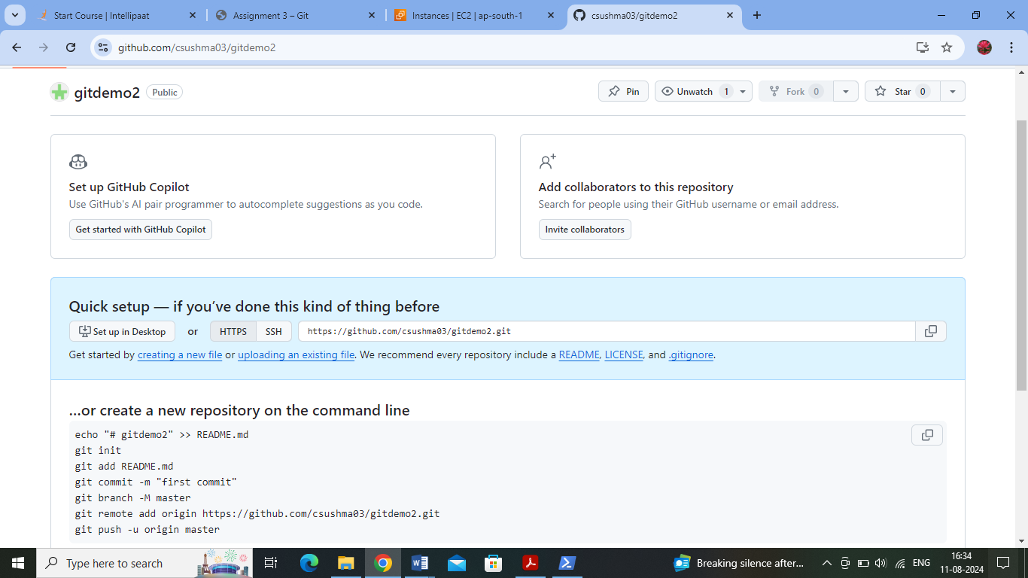

**Creating fine grained access tokens – to access the github from local machine** :

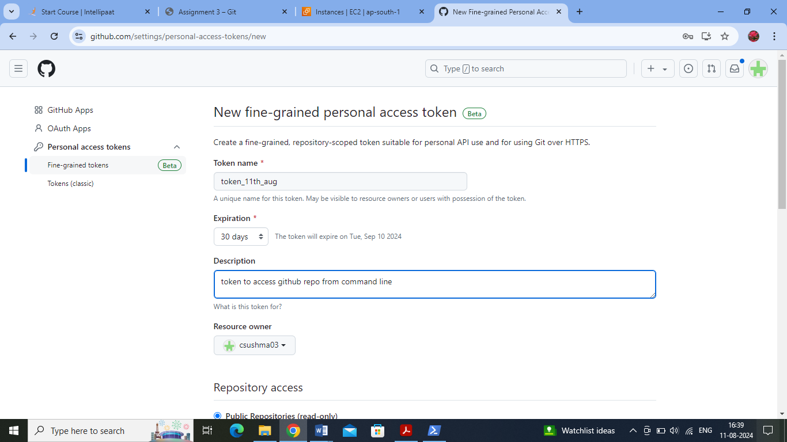

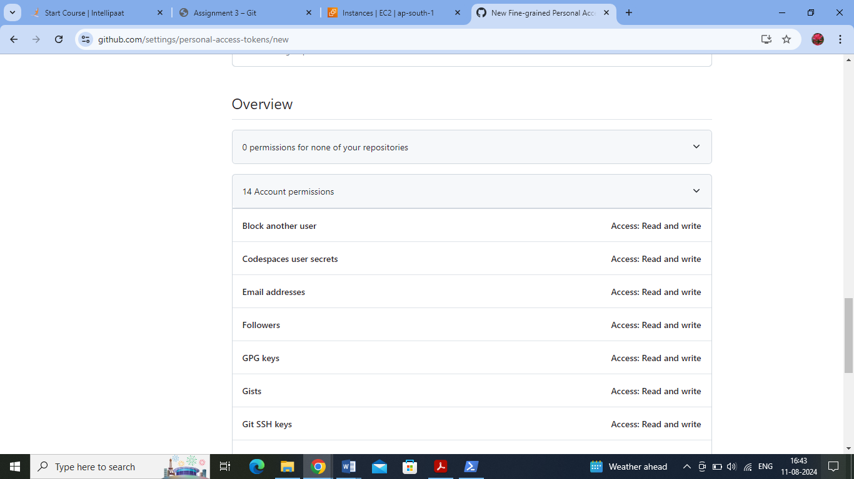

All Account and Repository permissions (read and write access) are given:

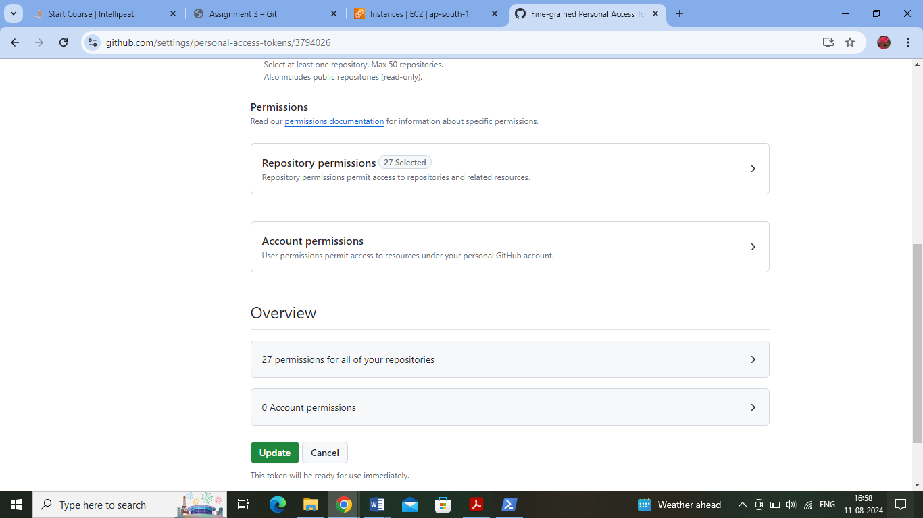

The Github repo link is added as remote origin using -git remote add origin “git hub url”

* The local branches are then pushed one by one to the github remote repo
* The fine grained access token is given for authentication
* Master branch is pushed to remote repo

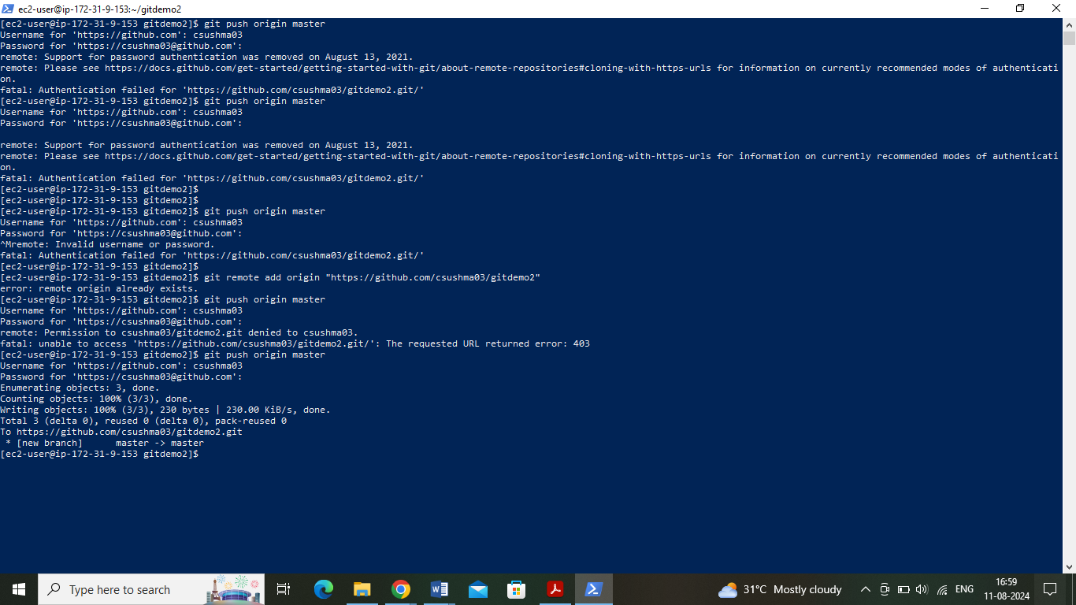

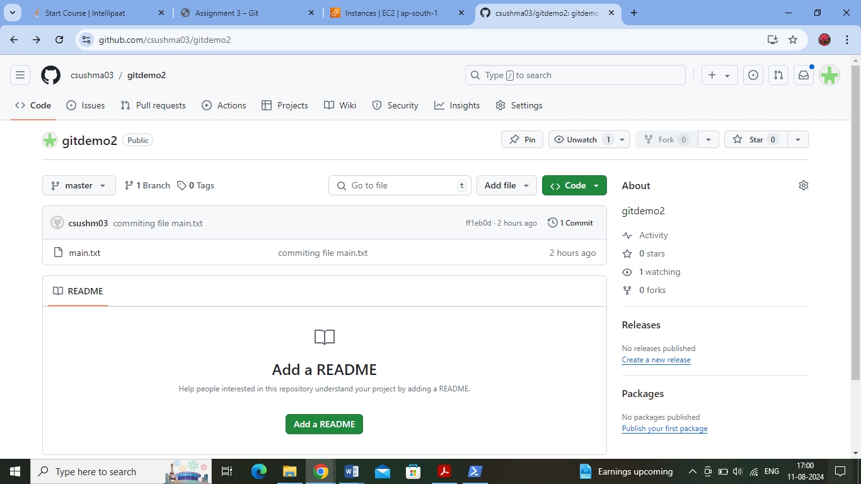

Develop, f1 and f2 branches are pushed to remote repo :



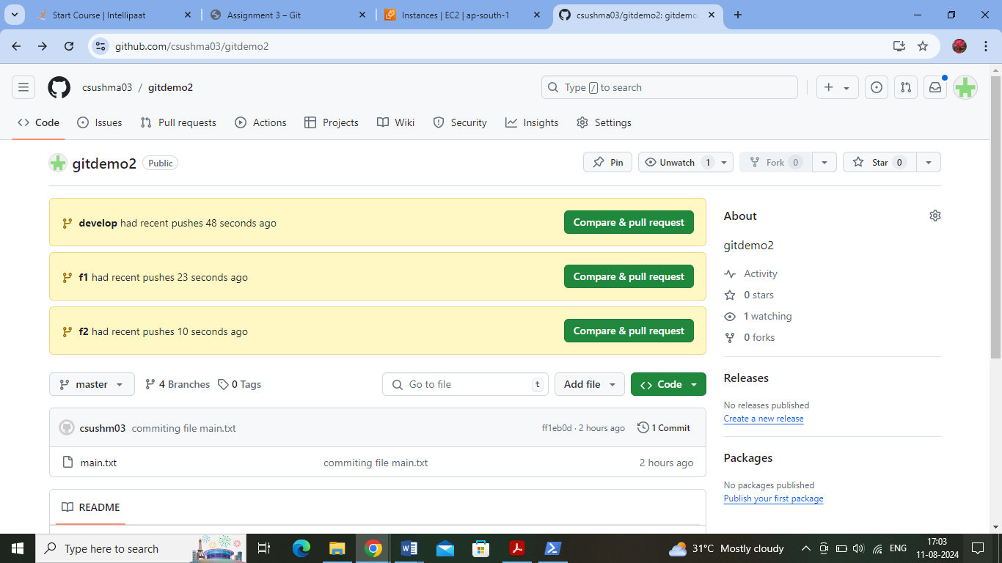

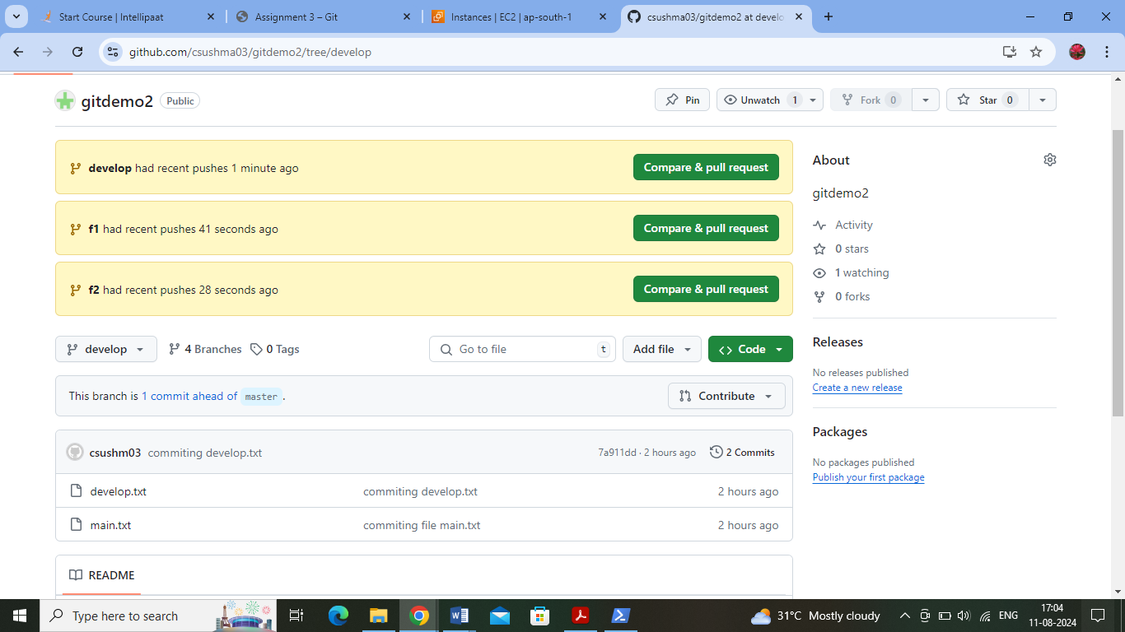

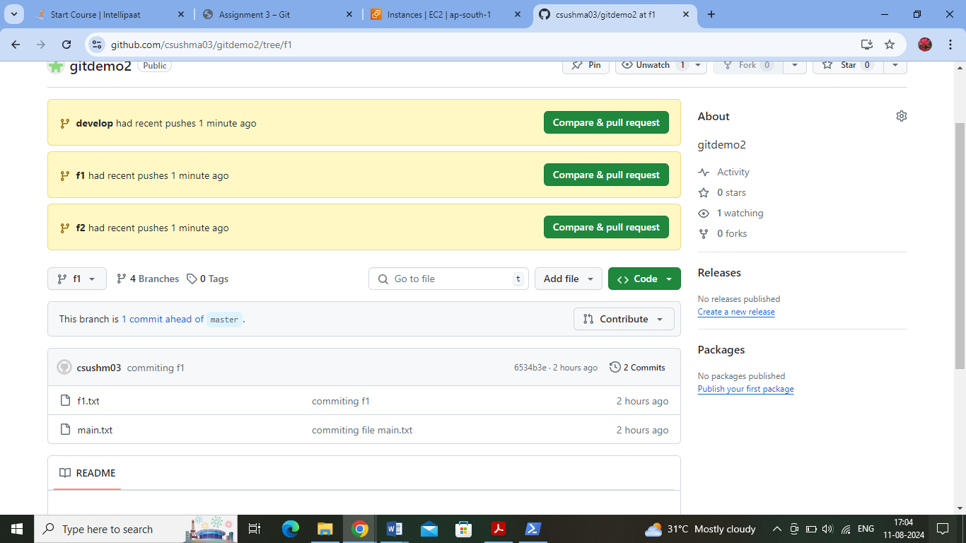

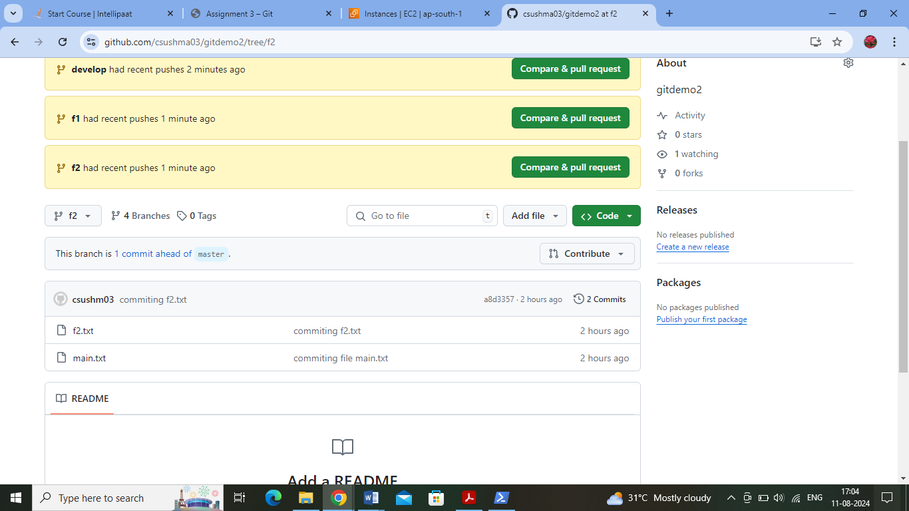

Deleting f2 branch on local repo:

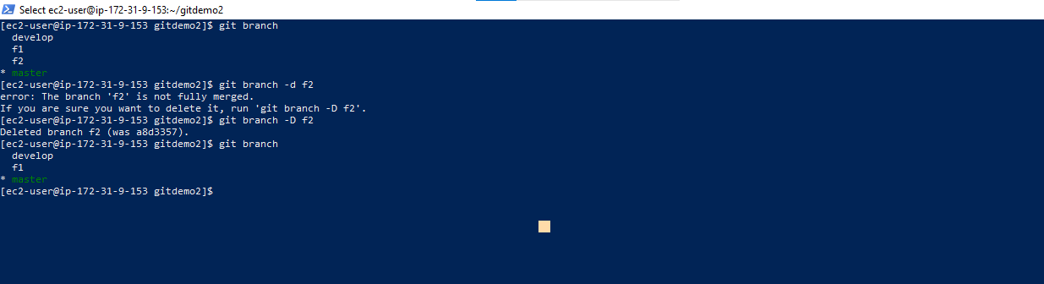

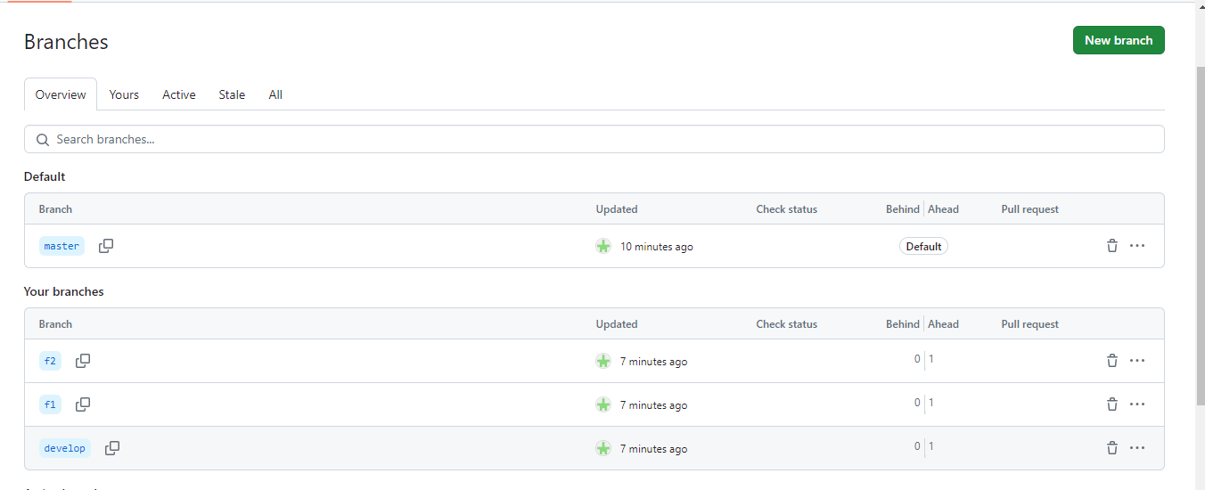

Deleting f2 branch on remote repo:

